**Book RECOMMENDATIONS**

<https://www.goodreads.com/list/show/2681.Time_Magazine_s_All_Time_100_Novels>

<https://thegreatestbooks.org/>

**What I'm Reading:**

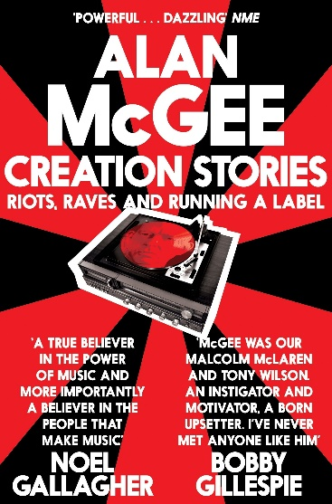

**The Last Book I Read:**

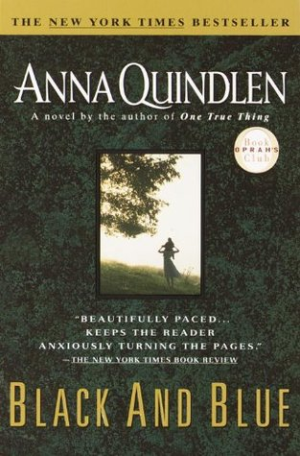

**Favorite Book:**

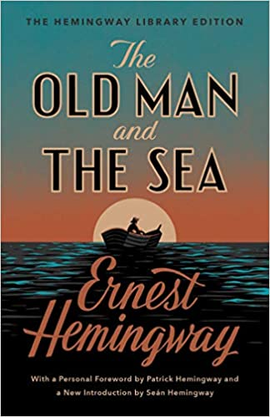

**What I'm Reading:**

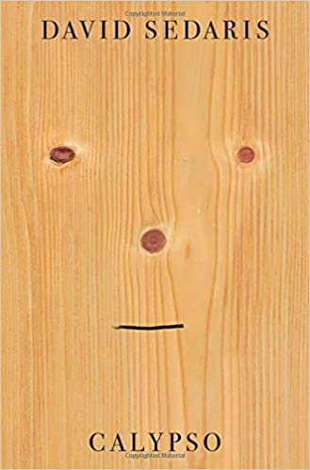

**The Last Book I Read:**

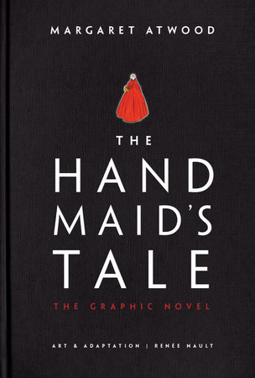

**Favorite Book:**



**What I'm Reading:**

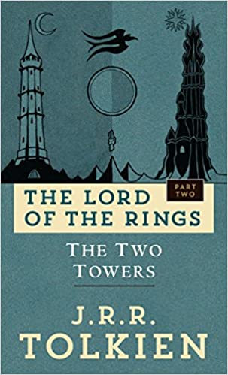

**The Last Book I Read:**

